Instruct-Seg-Edit
KP Sai Praneeth; 230968248

This project advances the field of controllable AI by explicitly addressing the "black box" nature of current editing models, providing both technical innovation and practical utility for real-world applications.

Problem Statement
Current instruction-based image editing models like InstructPix2Pix learn localization and editing implicitly, leading to unintended modifications outside desired regions and limited user control. There is a critical need for more precise, controllable, and interpretable editing systems.
Core Challenge: How can we explicitly disentangle the "where to edit" decision from the "what to edit" execution, while enabling interactive user refinement for perfect control?

Novel Contribution
This project introduces Instruct-Seg-Edit - a novel two-stage architecture that explicitly separates localization from editing, combined with an interactive refinement interface that allows users to correct predicted edit masks before final generation.
Key Innovations:
1. Disentangled Control: Explicit separation of localization from editing tasks.
2. Supervised Attention: Direct ground-truth supervision for attention mechanisms using edit masks.
3. Human-in-the-Loop Interactivity: User refinement of predicted editing regions.
4. Interpretable Editing: Explicit visualization of where the model thinks edits should occur.

Approach

Dataset Generation
This project requires deriving a dataset from existing datasets. The main components of the dataset are:
- Original Image
- Captions
- Edit Instructions
- Edited Image
- Edit Mask
The datasets available to the public only provide the original image and its captions. So, we derive rest of the elements using open-source tools and models.
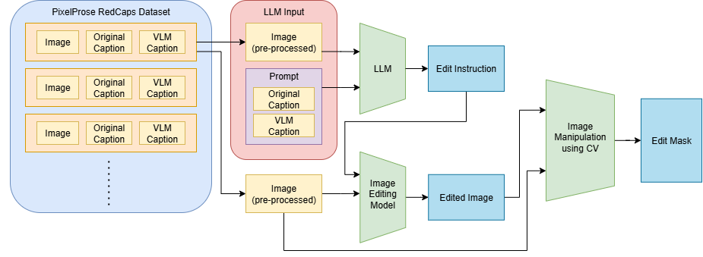
Figure 1: Dataset Generation Pipeline

1. Source Images: PixelProse Image dataset from huggingface. PixelProse is a comprehensive dataset of over 16M (million) synthetically generated captions, leveraging cutting-edge vision-language models (Gemini 1.0 Pro Vision) for detailed and accurate descriptions.
2. Instruction Generation: gemma3-4b-it vision language model which has the ability to understand the image with internal reasoning and generate desirable edit instructions for the image. The model is inferred locally using LM Studio API.
3. Image Editing: InstructPix2Pix model is used for editing the image conditioned on the instruction, which is generated in the previous stage. While the model is based on Stable Diffusion, it provides one of the best results during its inference. The model is also small enough for local inference with batching.
4. Ground Truth Masks: Edit masks are computed using computer vision techniques with the help of pixel difference and morphological operations.

Architecture
The project follows a two-stage architecture to tackle the problem statement separately. Developing a workflow that requires disentangling the localization of image editing and generating edits in that particular segment requires building of two models.

Localization Model
- Inputs: Original image, edit prompt.
- Image Encoder: Pre-trained Vision Transformer (ViT) or CLIP Image Encoder.
- Text Encoder: CLIP text encoder for instruction and caption embeddings. Other text embedding models can be used, but CLIP encoder is trained on image conditioning which makes it near perfect for this use-case.
- Fusion Module: Hybrid Attention mechanism that utilizes concepts from self-attention and cross-attention to provide a good fusion between image and text latents.
- Segmentation Decoder: U-Net style decoder producing predicted edit mask.
- Loss Function: $L_{localization}=L_{BCE}\left(M_{pred},M_{gt}\right)+L_{Dice}\left(M_{pred},M_{gt}\right)$
- Outputs: Edit mask which localizes the segment to be edited.

Mask-Conditioned Diffusion Model
- Inputs: Original image, edit prompt, predicted/refined mask,
- Base Model: Adapted Pix2Pix HD or latent diffusion model.
- Mask Conditioning: Concatenate mask as additional input channel (4-channel: R, G, B, Mask)
- Masked Loss: $L_{editing}=L_{1}\left(\left|I_{generated}-I_{target}\right|⊙M_{gt}\right)$
- Focus: Edit quality only within masked regions.
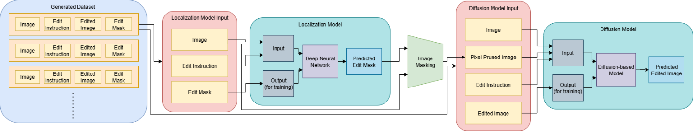
Figure 2: Workflow Pipeline

Model Comparison Matrix
Type | Model Name | Advantages | Disadvantages
Image Encoder | ViT-B/16 | Strong patch-based attention, excellent for segmentation, pre-trained on diverse data. | Moderate computational cost, requires 224×224 input.
Image Encoder | ResNet-50 | Lightweight, fast inference, hierarchical features. | Limited global context, weaker fine-grained localization.
Image Encoder | Swin Transformer | Hierarchical attention, excellent performance. | Higher memory usage, complex architecture.
Image Encoder | ConvNeXt-Base | Modern CNN design, efficient. | Less interpretable attention, newer architecture.
Image Encoder | EfficientNet-B4 | Extremely efficient, reliable performance/cost ratio. | Limited capacity for complex scenes.
Text Encoder | CLIP Text Encoder | Vision-language alignment, robust instruction understanding. | Limited to 77 tokens, fixed vocabulary.
Text Encoder | BERT-Base | Strong language understanding, flexible fine-tuning. | No vision alignment, domain gap.
Text Encoder | T5-Small | Generative capabilities, good instruction following. | Higher memory, not vision-aligned.
Text Encoder | SentenceBERT | Excellent sentence embeddings, efficient. | Not optimized for vision tasks.
Text Encoder | RoBERTa-Base | Robust language understanding, good generalization. | No multimodal training, domain adaptation needed.
Base Editing Model | Stable Diffusion v1.5 + ControlNet | Excellent image quality, flexible conditioning, mask support. | High VRAM usage, complex training.
Base Editing Model | Pix2Pix HD | Efficient training, good for paired data. | Limited generative capability, older architecture.
Base Editing Model | DDIM + U-Net | Decent quality, controllable generation. | Complex training, less stable.
Base Editing Model | CycleGAN | Unpaired training possible, efficient. | Limited instruction following, style-focused.
Base Editing Model | StyleGAN2 + Projection | Excellent quality, latent manipulation. | Limited to specific domains, complex editing.
Segmentation Decoder | U-Net with Skip Connections | Proven for segmentation, preserves delicate details. | Standard architecture, not cutting-edge.
Segmentation Decoder | DeepLab v3+ | Atrous convolutions, multi-scale features. | Higher complexity, more parameters.
Segmentation Decoder | Mask2Former | State-of-the-art segmentation, transformer-based. | Higher VRAM, complex training.
Segmentation Decoder | PSPNet | Pyramid pooling, good context modeling. | Less detailed boundaries.
Segmentation Decoder | FPN (Feature Pyramid Network) | Multi-scale features, efficient. | Requires careful tuning, less specialized.

Expected Outcomes
Quantitative Metrics
Localization Performance:
- Intersection over Union (IoU) for mask prediction accuracy
- Dice Coefficient for segmentation quality
- Precision/Recall for edit region detection
Editing Performance:
- LPIPS (perceptual similarity) within masked regions
- FID scores for overall image quality
- CLIP similarity between edited result and text prompt

Qualitative Analysis
- Interactive demo highlighting mask prediction and refinement.
- Visual comparisons of two-stage vs. end-to-end approaches.
- Case studies proving improved control and interpretability.
- Analysis of failure modes and model limitations.

